***INSTALL MS SQL SERVER :***

1. Go to Google and type Microsoft SQL server download
2. Click on the SQL server download

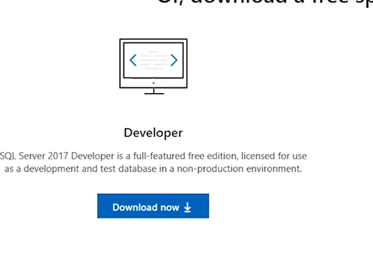

1. Download the developer version
2. Click on the downloaded file
3. A pop-up will appear click on the custom

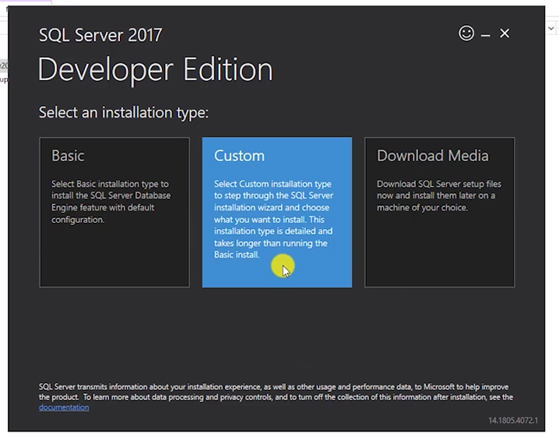

1. You find the media location and click on next
2. 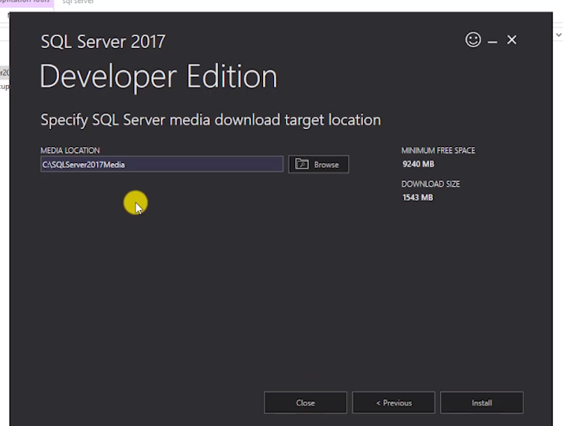
3. A pop-up will appear now click on install and select new SQL server stand-alone installation

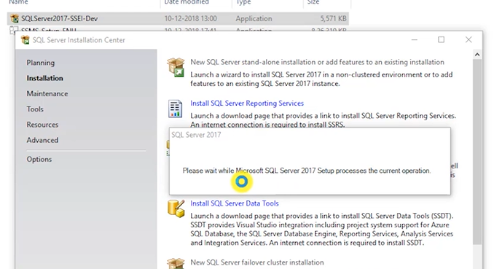

1. A pop-up will appear and click on next

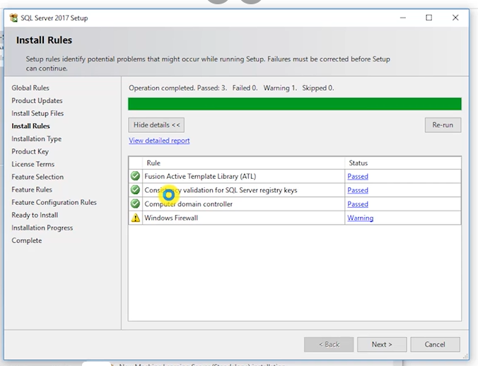

1. Select perform a new installation of SQL server and click on next 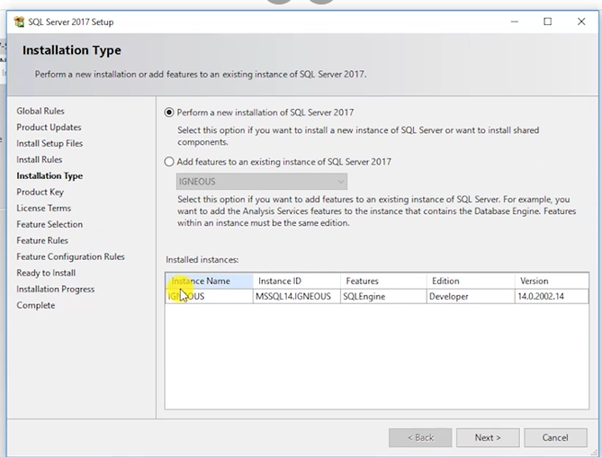
2. Select free addition and click next
3. Accept license agreement and click on next
4. Select database engine service

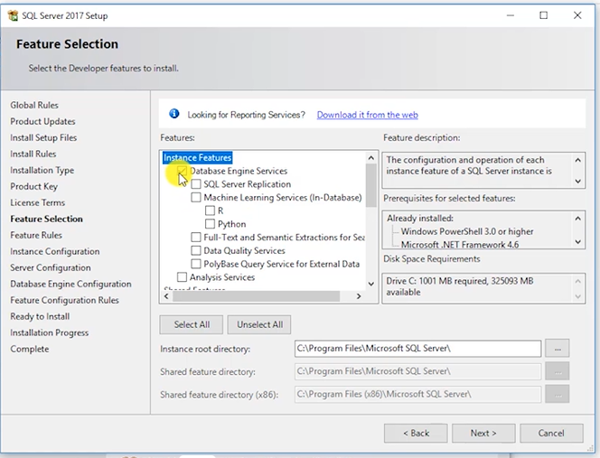

1. Name the instance and click on next
2. Click on next and select mixed mode and set password and add current user and click next
3. And now click on install
4. Once the SQL server is installed now install SQL server management
5. Search on Google as install SQL server management
6. Download SQL server management studio
7. Click on the downloaded file and click on install and SQL server management will be installed

***CHAR VS VARCHAR :***

| CHAR | VARCHAR |
| --- | --- |
| Char datatype is used to store string datatype of fixed length | Char datatype is used to store string datatype of variable length |
| If the length of the string is less than set length then it is padded with extra memory space | If the length of the string is less than the set length then it will store as it is without padded with extra space |
| Char stands for character | Varchar stands for variable character |
| Storage size of char datatype is equal to n bytes i.e., set length | The storage size of the varchar datatype is equal to the actual length of the entered string in bytes |
| We should usre the char datatype when we experct the data values in a column are of the same length | We should use the varchar datatype when we expect the datat values in a column are of variable length |
| Char takes 1 bytes for each character | Varchar takes 1 byte for each character and some extra bytes for holding length information |
| Better performance than varchar | Performance is not good as compared to char |

***TYPES OF SQL COMMANDS:***

We have four commands in SQL, they are as follows:

1. DQL
2. DDL
3. DML
4. DCL

DQL:

DQL stands for Data Query Language. DQL helps us in selecting query

DDL:

DDL stands for Data Definition Language. DDL helps us in defining and altering and drop a query

DML:

DML stands for Data Manipulation Language. DML helps us in manipulating as insert and update and deleting data in query

DCL:

DCL stands for Data Control Language. DCL helps controlling data as to grant any query and revoke any query

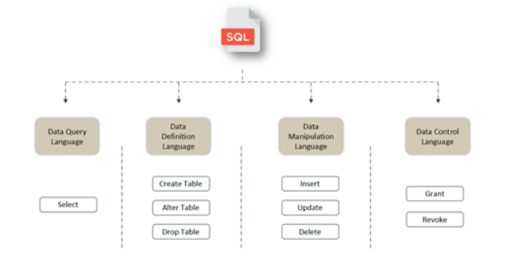

***NVARCHAR VS ACHAR:***

| NCHAR | NVARCHAR |
| --- | --- |
| Unicode fixed length can store both non Unicode and Unicode characters i.e., Japanese, Korean…. | Unicode variable length can store both non-Unicode and Unicode characters i.e., Japanese, Korean…. |
| Maximum length up to 4000 characters | Maximum length up to 4000 characters |
| Takes up 2 bytes per Unicode/nonunicode characters | Takes up 2 bytes per Unicode/nonunicode characters |
| 2 times n bytes | 2 times actual length in bytes |
| Used only if you need Unicode support | Used only if you need Unicode support |